School going children in the Netherlands
In this article I will explain some of the Dutch traditions and things children come across every day.
School
When you are 6 years old, you learn how to read and write in the 3rd grade of primary school. Every year from that moment on you are going to learn more interesting things in class. The last year of primary school (the 8th grade ) is the most enjoyable. In this grade, you will do a school exam to determine the level of education you need but more importantly you will perform a musical, go on camp and do more amusing things.
Sinterklaas
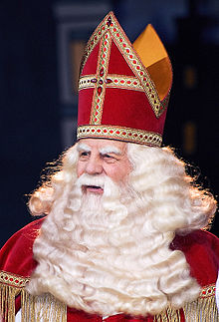
The Dutch child friend. This man celebrates his birthday by giving all the children in the Netherlands a bag full of presents. His servants put the presents in front of doors, whilst they throw some candy in the room. Unfortunately this man doesn’t really exist, your parents buy the presents and celebrate the holiday with you. One of the well-known songs is:
Sinterklaas kapoentje,
Gooi wat in mijn schoentje,
Gooi wat in mijn laarsje,
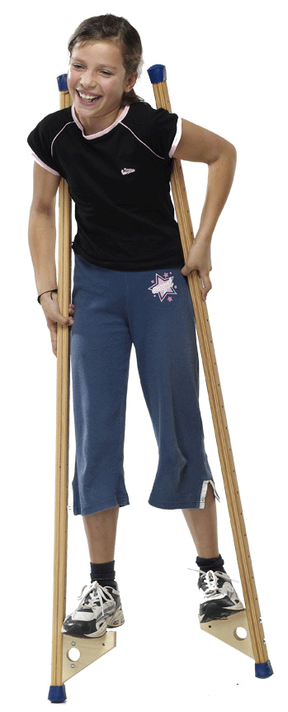
Dank u Sinterklaasje

Stilts
Stilts are a common way for children to play outside. Stilts are long sticks with two foots on them. Children stand on these foots and try to walk on the stilts. This can be quite tricky because you have to control your own feet and the stilts. Some people eventually make walking on stilts their job.

Jeroen Hofland
V3B

